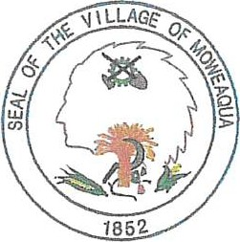
Village of Moweaqua

SPECIAL MEETING
September 19, 2022

Village of Moweaqua 5:00P.M.

Call to Order Pledge to the Flag Roll Call

AGENDA
- Discussion and Possible Action Regarding OSHA Compliance and Payment of Fine- Mayor Conlin
- Discussion and Possible Action Regarding Lions Club Building - Mayor Conlin
- Discussion and Possible Action Regarding ACTS Phone System- Mayor Conlin
- Discussion and Possible Action Regarding Quote for Sidewalk Work-Brad Sams
- Approval to Pay Illinois Meter Company Invoice #3035127-00 for Putnam Water Main Project from ARPA Funds - Mischelle Davis

Adjourn

